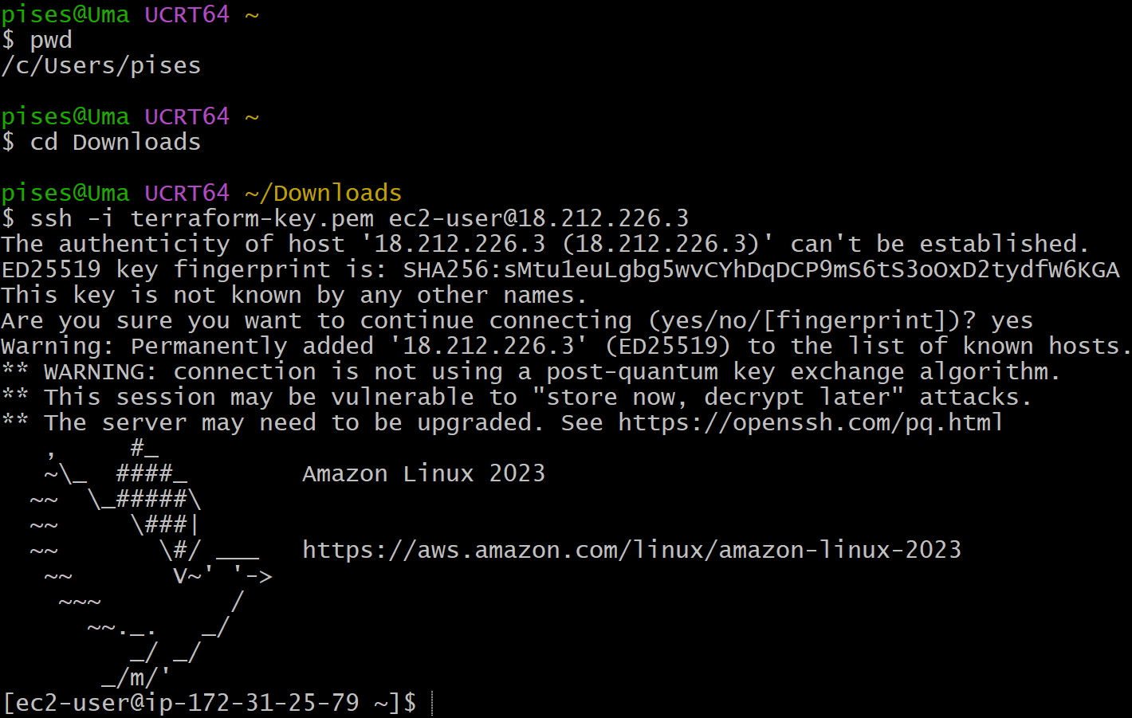
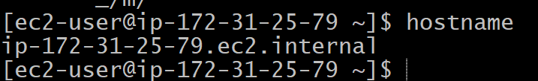
Hostname: name given for computer server
sudo hostnamectl set-hostname webserver
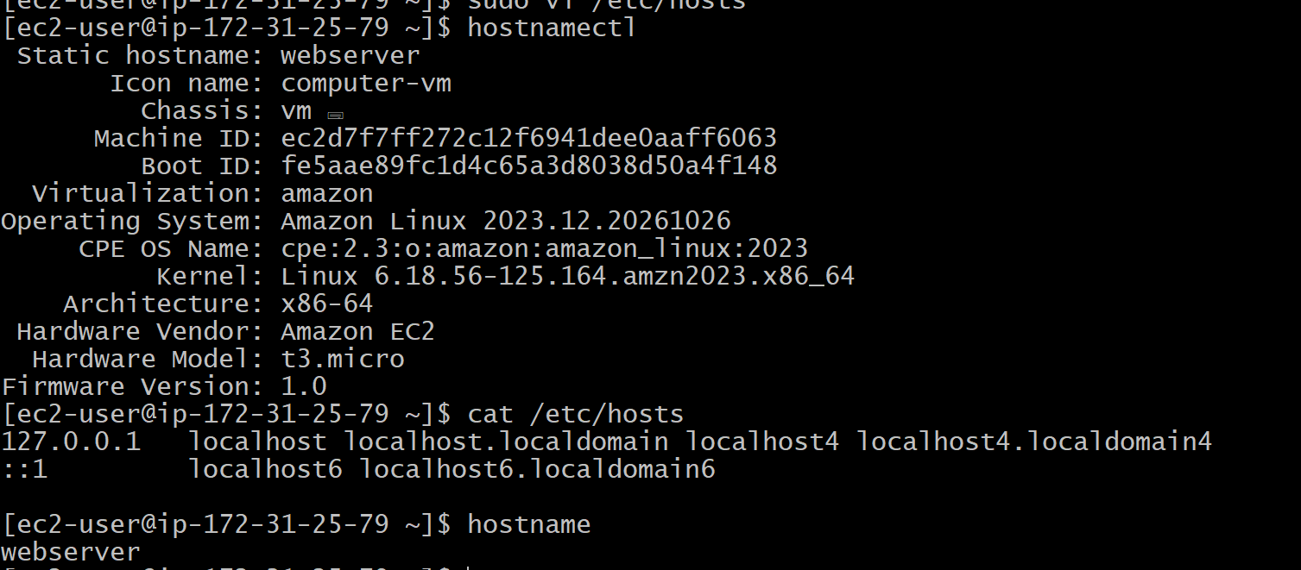
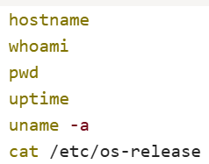
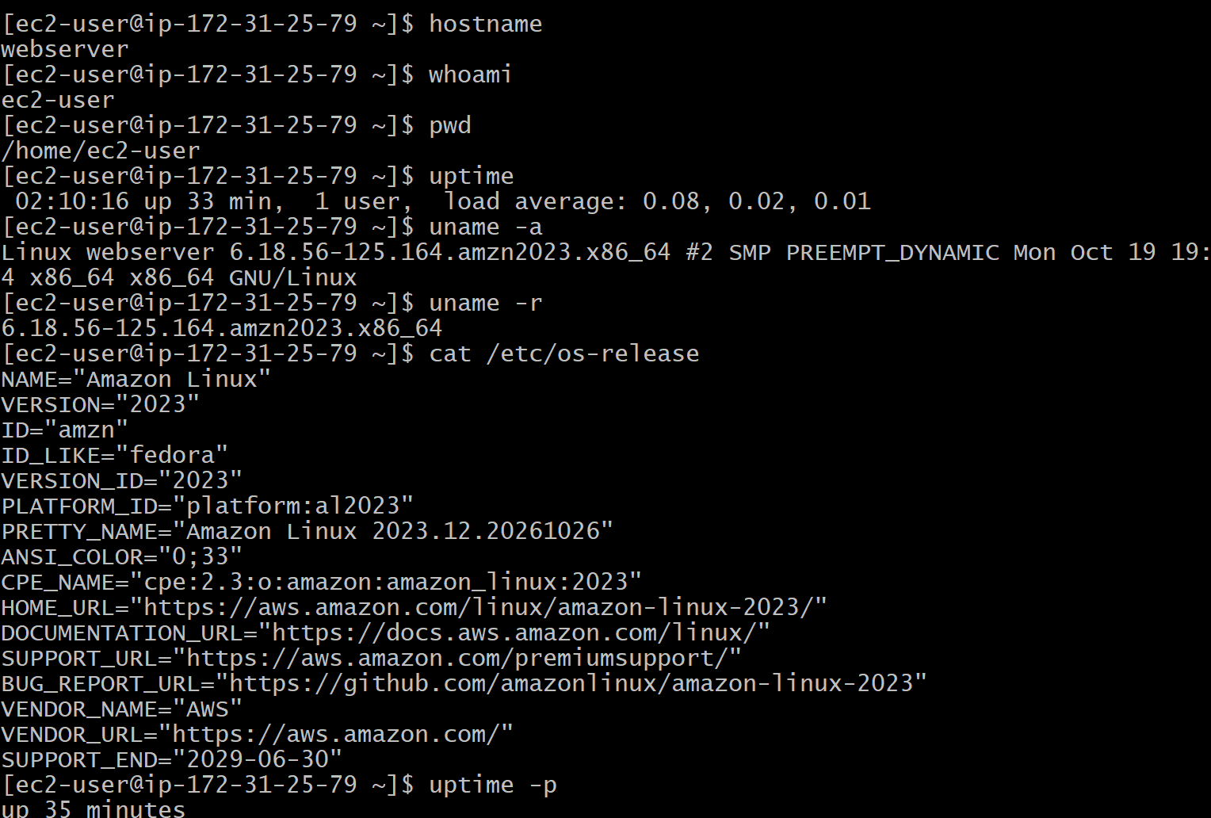
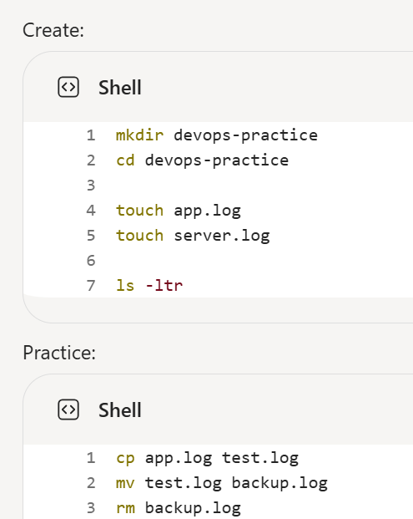
sudo useradd devopsuser
sudo passwd devopsuser
id devopsuser
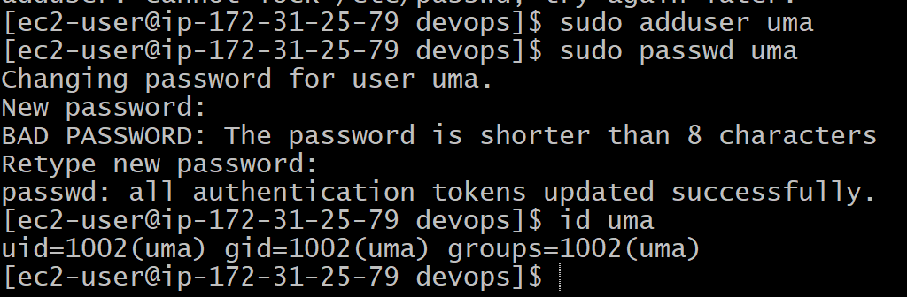
df -h
du -sh *
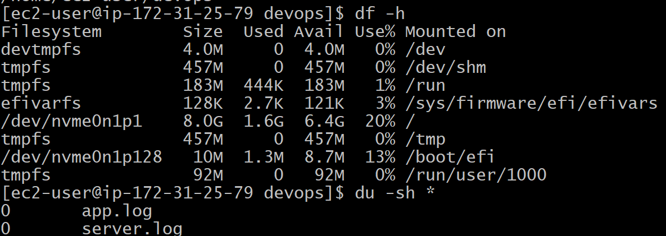
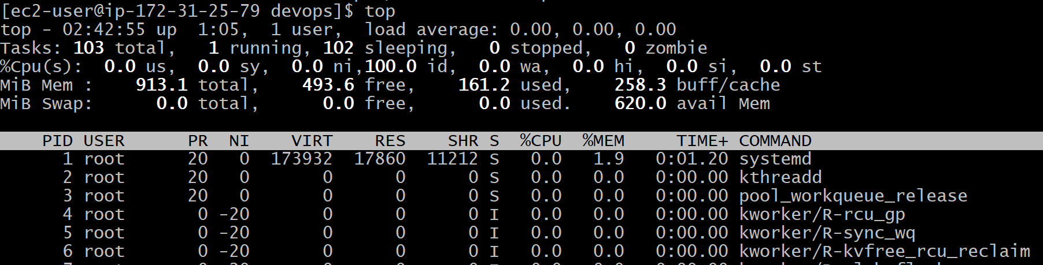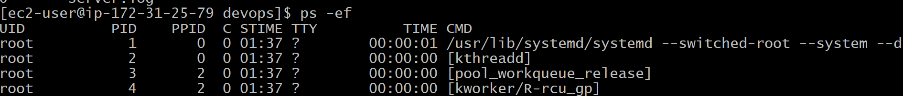

Install Nginx
Sudo yum update -y
Sudo yum install nginx -y
Sudo systemctl start nginx
Sudo systemctl enable nginx(it configure nginx to start automatically whenever system boots up)
Sudo systemctl enable nginx
Port Verification
sudo netstat -tulpn or ss -tulpn

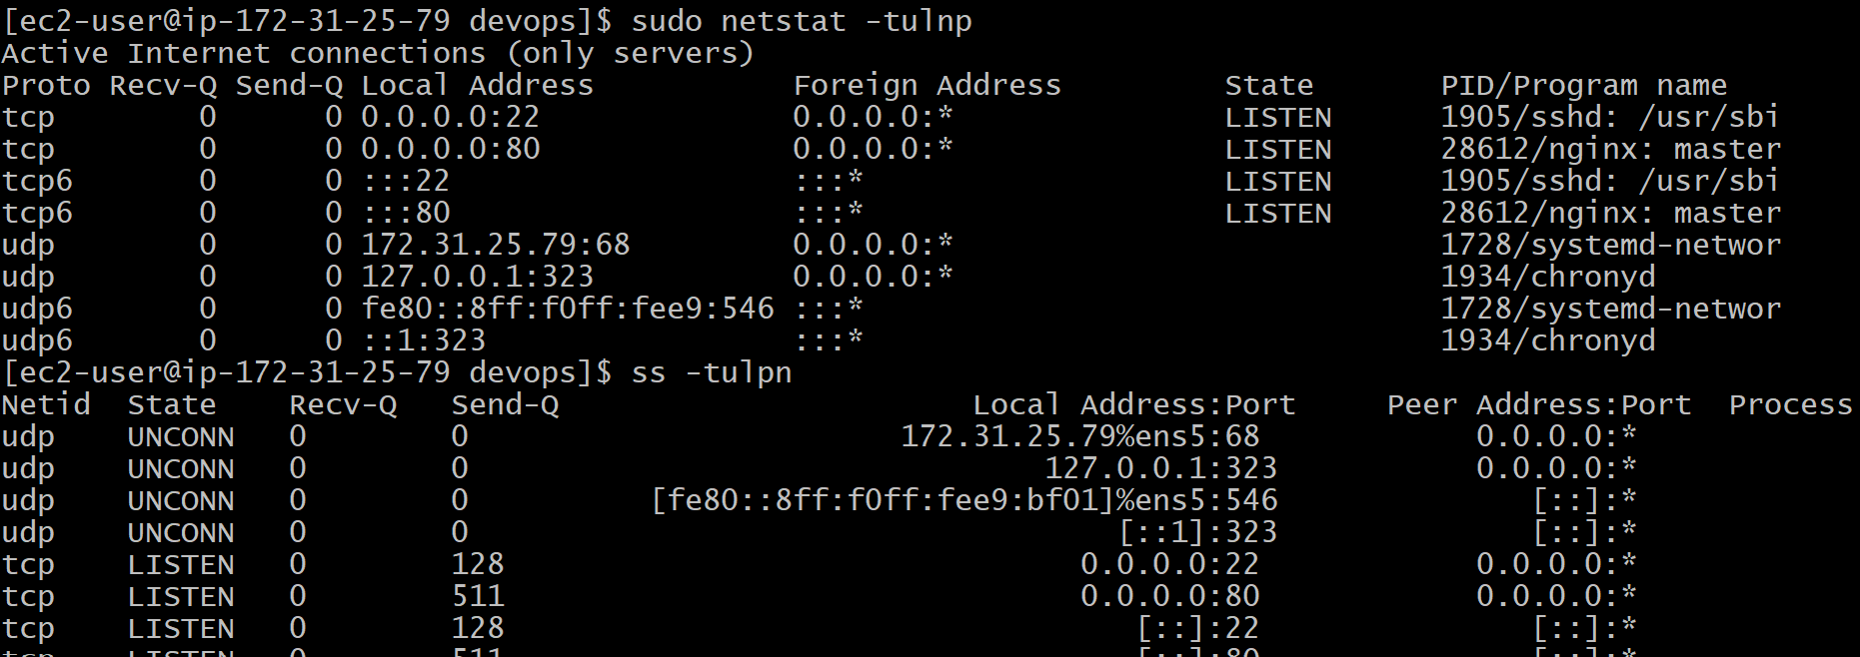
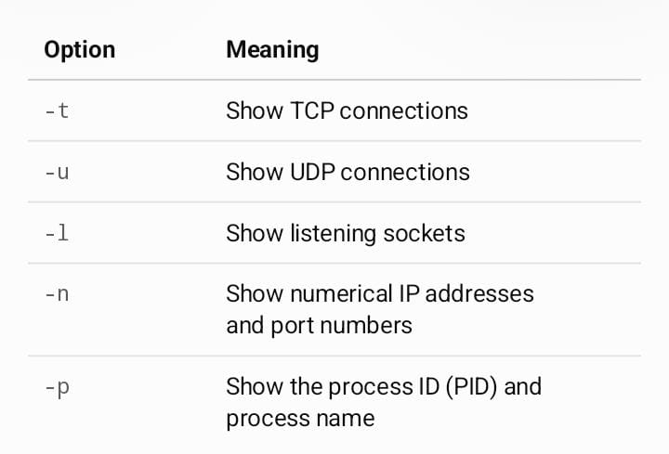
Log Analysis
sudo tail -f /var/log/messages
journalctl -xe

Networking
ping google.com
curl ifconfig.me
nslookup google.com
